SOFTWARE PROJECT 2
Project 2 — Predictive Analytics
Predicting Titanic Passenger Survival
Dataset: titanic.csv (891 records)
Prepared by: dhanesh kumar
Course: software project 2 / predictive
Date: July 11, 2026

1. Introduction & Business Objective
Predictive analytics answers "what is likely to happen?" by learning a pattern from historical, labeled data — cases where the outcome is already known — and using that pattern to predict outcomes for new cases. This project uses the classic Titanic passenger dataset as a stand-in for that workflow: given a passenger's characteristics, can we predict whether they survived? The exact same supervised-classification pipeline used here — clean data, engineer features, train a classifier, evaluate with precision/recall/ROC-AUC — is the standard template for real business predictive analytics: customer churn, loan default, or insurance-claim prediction. Only the label and features change.

2. Dataset Description
The analysis uses the Titanic passenger dataset (891 records before cleaning), a different dataset from Project 1, containing demographic and travel details plus the known survival outcome.
Column | Description
survived | Target: 1 = survived, 0 = did not survive
pclass | Ticket/passenger class (1st, 2nd, 3rd)
sex, age | Passenger demographics
sibsp, parch | Number of siblings/spouses and parents/children aboard
fare | Ticket fare paid
embarked | Port of embarkation (C, Q, S)

3. Methodology

3.1 Importing Libraries and Loading the Data
In addition to pandas/numpy/matplotlib/seaborn, scikit-learn supplies the train/test split, the Logistic Regression and Random Forest classifiers, feature scaling, and the evaluation metrics (accuracy, precision, recall, F1, ROC-AUC, confusion matrix).

3.2 Data Cleaning and Preprocessing
Age is missing for about 20% of passengers and embarked for 2. Age is imputed using the median within each passenger-class-and-sex group — a first-class woman and a third-class man have very different typical ages, so a single overall median would be a worse estimate than a group-aware one. The 2 missing embarked values are filled with the most common port.

3.3 Duplicate Removal
113 of 891 rows (12.7%) are exact duplicates. An important caveat is stated explicitly in the report rather than glossed over: this simplified version of the dataset has no passenger ID, name, or ticket number, so some “duplicates” may be genuinely different passengers who share the same class/sex/age/fare/embarkation combination rather than true data-entry errors. The mandatory de-duplication step is still applied — with no identifier to disambiguate them, exact-duplicate rows carry no additional information for the model either way.

3.4 Feature Selection
Several columns are dropped as redundant or leaky: alive is simply survived re-spelled as text (keeping it would let the model see the answer directly); class, who, adult_male, and embark_town duplicate information already captured by pclass, sex+age, and embarked; deck is 77% missing; and alone is a deterministic function of sibsp and parch, already in the model.

3.5 Encoding Categorical Attributes
sex is mapped to a binary 0/1. embarked has no natural order (it is a port name, not a ranked category), so it is one-hot encoded rather than given an arbitrary ordinal encoding.

4. Exploratory Data Analysis
Survival was strongly stratified by sex (74% for women vs. 22% for men) and by passenger class (64% in 1st class vs. 26% in 3rd) — consistent with the historical “women and children first” evacuation norm and first-class passengers' proximity to lifeboats. This suggested sex and pclass would be the model's strongest predictors, which is verified in Section 5.
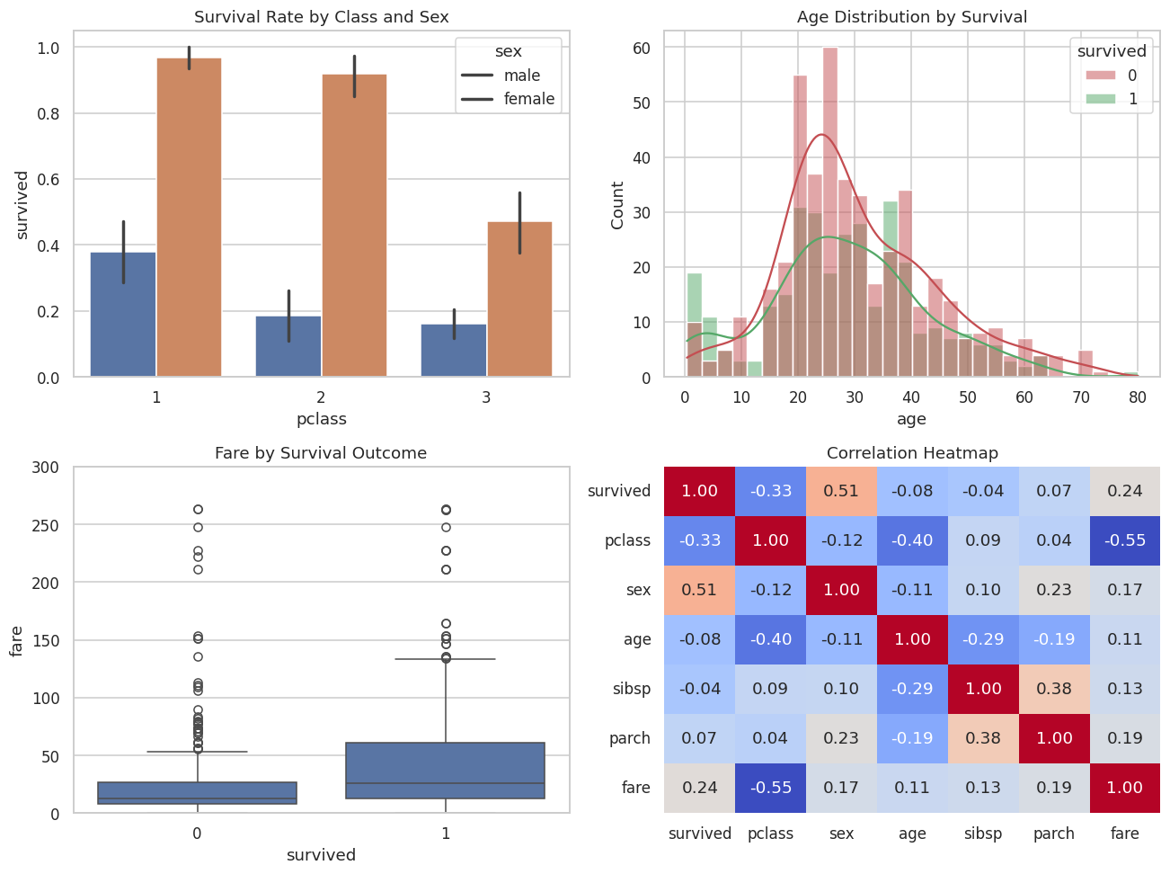
Figure 1. Survival rate by class/sex, age distribution by outcome, fare by outcome, and the correlation heatmap.

5. Model Building & Evaluation
The cleaned data is split 80/20 into training and test sets (stratified on the target to preserve the survival rate in both splits). Two classifiers are trained and compared on the held-out test set: Logistic Regression, a simple and highly interpretable baseline, and Random Forest, a more flexible ensemble model capable of capturing interactions such as “being a child and in third class.”
Model | Accuracy | Precision | Recall | F1 | ROC-AUC
Logistic Regression | 0.808 | 0.746 | 0.815 | 0.779 | 0.874
Random Forest | 0.827 | 0.852 | 0.708 | 0.773 | 0.872
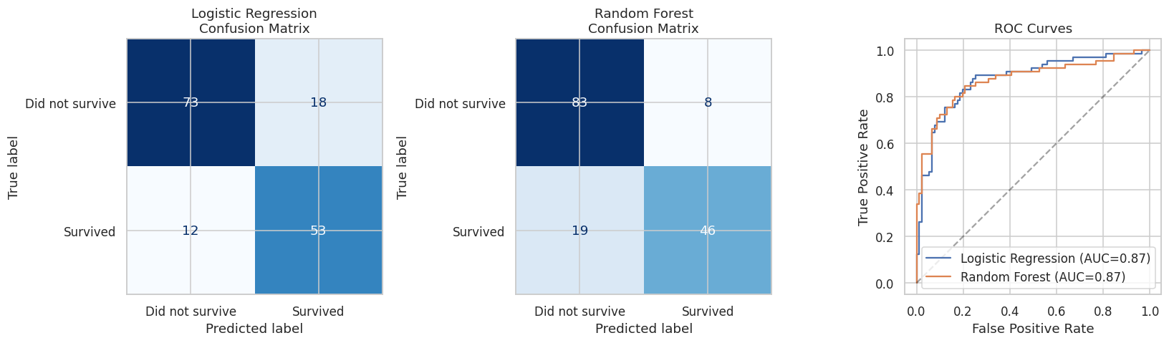
Figure 2. Confusion matrices for both models and their ROC curves.
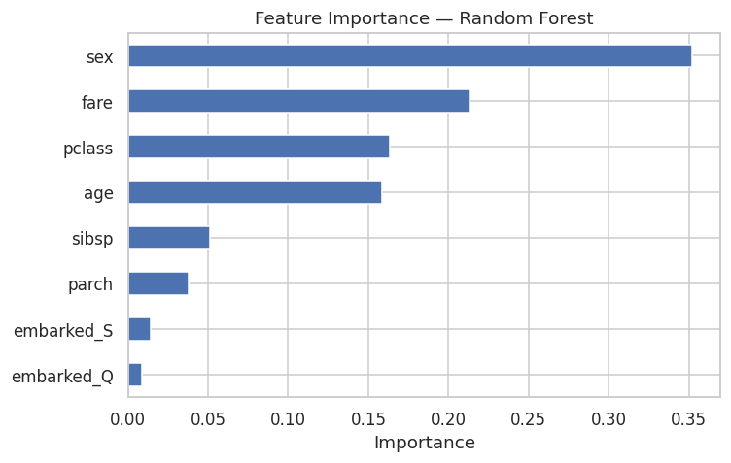
Figure 3. Random Forest feature importance ranking.

6. Results Interpretation & Discussion
- Both models score well above the 50% random baseline; Logistic Regression edges out a slightly higher ROC-AUC, while Random Forest achieves higher precision, illustrating a genuine accuracy/precision-recall trade-off rather than one model being simply “better.”
- Feature importance confirms the EDA: sex is by far the strongest predictor, followed by fare/pclass (proxies for socioeconomic status and cabin location), then age.
- In a real safety-planning context, recall on at-risk cases often matters more than raw accuracy — missing an at-risk case is usually costlier than a false alarm. The confusion matrices let a stakeholder see that trade-off directly rather than relying on one number.
Where this generalizes: replace “passenger” with “customer” and “survived” with “churned,” “defaulted,” or “converted,” and this exact pipeline — clean, encode, split, train, evaluate, inspect feature importance — is the standard template for real business predictive analytics.

7. Conclusion
This project demonstrates a complete predictive-analytics workflow on a labeled classification problem: careful handling of missing data and potential target leakage, encoding, model comparison, and a multi-metric evaluation that goes beyond a single accuracy figure. The resulting model and its feature-importance ranking are directly interpretable and transferable to analogous binary-outcome business problems.

